**2. Finite State Automaton for Strings Ending with 'ab'**

**Aim:**  
To create a finite state automaton that recognizes strings ending with 'ab'.

**Algorithm:**

1. Define states and transitions.
2. Check if the input string ends with 'ab'.
3. Implement transitions to move between states based on input.
4. Accept the string if it ends in the final state.

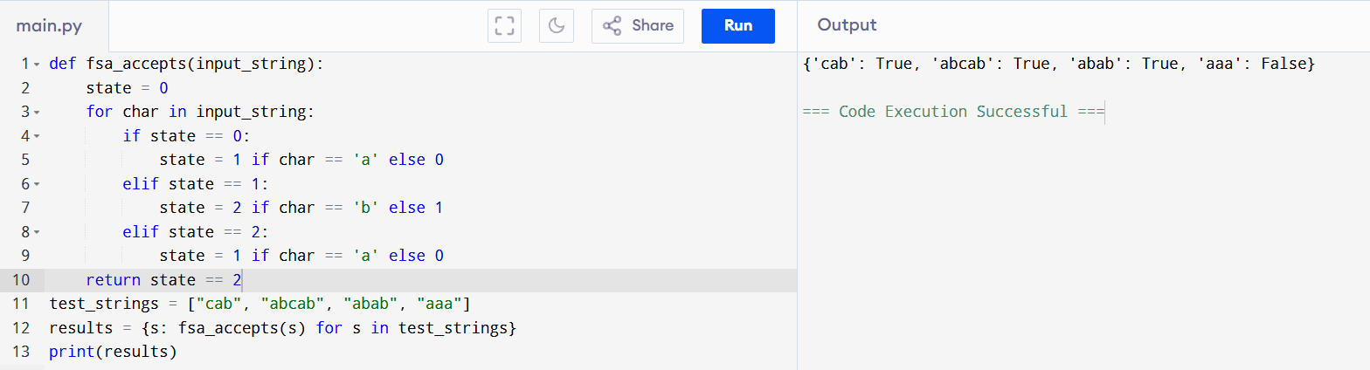

**Result:**  
The finite state automaton correctly identifies strings ending with 'ab'.